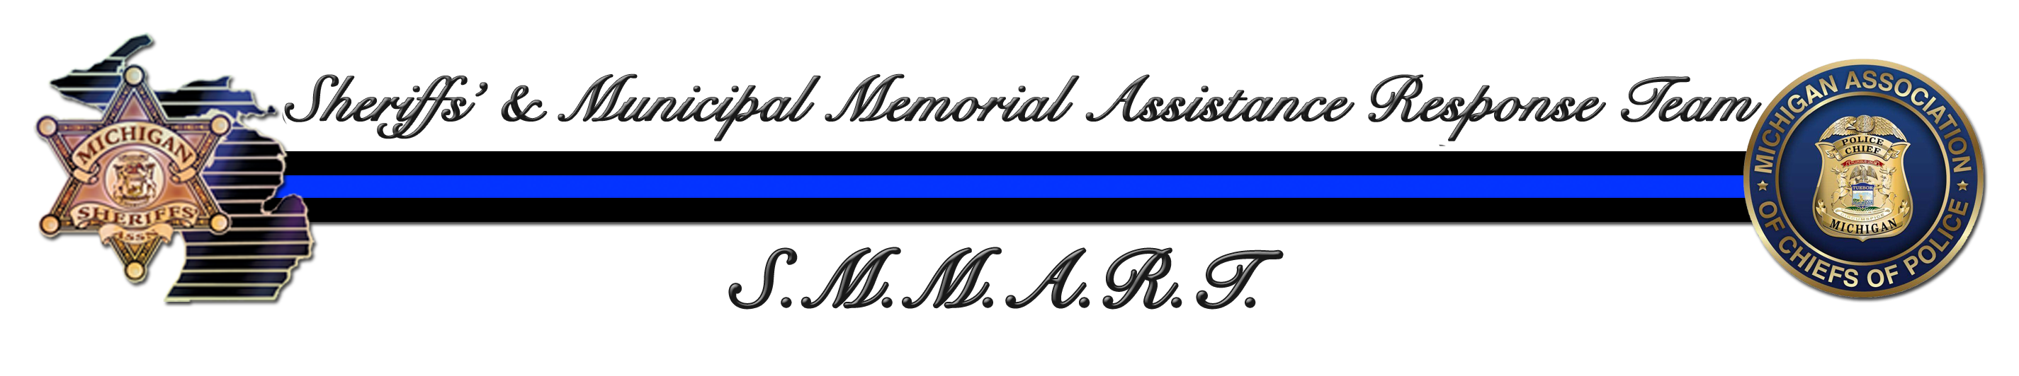
To All,

Thank you for your interest in attending the S.M.M.A.R.T. (Michigan Sheriff's & Municipal Memorial Assistance Response Team) / DFL Honor Guard Training session August 25th – 29th, 2025 being held in Alpena, MI. This training is being co-hosted by the two foremost leading law enforcement organizations in the State of Michigan: The Michigan Sheriffs’ Association and the Michigan Association of Chiefs of Police.

Great care has been taken to ensure that students attending this class will be educated in proper flag law and flag etiquette when handling the National, State and Department colors, as well as funeral protocol & procedures when honoring a fallen Law Enforcement Officer or Fire Fighter who had died in the line of duty. A considerable effort has been placed forth by S.M.M.A.R.T. to exceed all expectations for the highest level of quality, training and educational experience that will be received by students who attend this class. We are confident that all who attend this training session will return to their respective agencies with a renewed sense of honor, pride, and the valuable tools necessary to execute many of the details your team may be requested to handle.

WELCOME TO DFL HONOR GUARD TRAINING

The Instructors for DFL Honor Guard Training are responsible for the same high-quality training experience as found at the nationally acclaimed Goshen, Indiana Honor Guard Camp. The combined training forums have successfully educated more than 7500 public safety officers from across the United States over the last two decades. All instructors attending this class are active members of their respective honor guard units or continue their involvement with memorial and ceremonial affairs and bring “real world” experiences to their instructions.

Our instructional cadre is comprised of experienced, highly dedicated individuals, many of whom have received training with the U.S. Army 3rd Infantry Regiment, “Old Guard” at Ft. Myer, Virginia (Arlington National Cemetery) and or the Air Force Ceremonial Honor Guard and are all dedicated to the Honor Guard Mission, motivated by one common goal; To do all that we can to insure that our Brothers and Sisters who give their lives in the Line-of-Duty properly receive all the honor and respect that they have earned and deserve.
The primary goal of the S.M.M.A.R.T. team for this program is to offer the finest quality educational and training experience possible to those agencies attending, while properly educating the Public Safety Officer in Honor Guard / Funeral Protocol, and at the same time keeping the over all cost of this training to a minimum. Because many agencies have an extremely limited training budget, and with the assistance of the United States Military, we have been able to negotiate arrangements with the 110th Airlift Wing of the Air National Guard at the Alpena Combat Readiness Training Center (CRTC) to offer two extremely reasonable and flexible pricing options for this class:
$825.00 / per student includes all training & instructional materials, uniform of the day to include: (1) cap / (1) sweatshirt / (2) t-shirts PLUS one (1) catered buffet lunch served each day (Monday – Thursday). NO LODGING.
$925. 00/ per student includes all the above PLUS three (3) buffet meals served each day consisting of (breakfast & dinner) Monday-Thursday and a catered lunch Monday-Thursday, lodging with check-in beginning on Sunday August 24th and check out / final exam concluding on Friday August 29th.
In addition, students will receive a light breakfast and luncheon on Friday and class challenge coin / certificate upon graduation.

ONLINE REGISTRATION WILL OPEN TUESDAY MARCH 18TH , 2025 AT APROXIMATELY 9:00AM..
**FOUR STUDENTS MAY BE REGISTERED AT ONE TIME**
For your convenience, online registration will be available by clicking on the training link at:
www.misheriff.org
We are asking that you complete the registration form as completely as possible including direct contact information (email address if possible) for each student as an additional class email will be sent prior to this class with important information each student will need. Please make every effort to provide accurate sizing for the uniform shirts ordered, once our order is placed a replacement or exchanged size will not be possible.
If you do not know the name and information of the student attending, you may still reserve your position listing the student as TO BE DETERMINED (in each space) and provide this information later. This will assist in reserving your needed space for this training.
While a completed registration form provides us with your interest and intentions on attending this class, registration without payment in full cannot be guaranteed and is due no later than fRIDAY, August 1st, 2025.

Due to the incredible response that has been received stemming from previous training classes, it is expected that this school will once again fill very fast. Once registrations have been received and the class has been filled to sixty (60) students, agencies submitting a registration will be placed on a standby / cancellation list on a first come / first registered basis. All departments are highly encouraged to register their officers even if the class has been filled as vacancies due to cancellation may become available. An established waiting list as well provides us with the necessary information on the interest for possible future classes and out of courtesy; departments who have registered and were placed on the waiting list will be provided with advance notification of any future training dates.

Contact: Should you need any additional training information, Ofc. Dan Foley, Wyandotte Police Department Honor Guard (Ret.) at axelf63@wyan.org, 734-365-3577 (cell). You may as well contact The Michigan Sheriffs Association at 517-485-3135 or Michigan Association of Chiefs of Police at 517- 349-9420.

Please look for an additional email that will be sent out to all registered points of contact with additional training information that you will need prior to your arrival onsite. This email will be sent out sometime in mid to late July.

Again, on behalf of the Michigan Sheriff's Association, The Michigan Association Chiefs of Police, S.M.M.A.R.T. and DFL Honor Guard Training, we thank you for your interest in attending this class and look forward to hearing from you soon.

Respectfully,
Dan Foley
Wyandotte Police Department (Ret.)

Memorial Affairs / Honor Guard Coordinator
Michigan Sheriffs & Municipal
Memorial Assistance Response Team (S.M.M.A.R.T.)
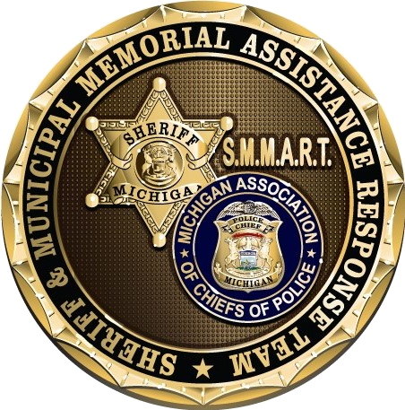

“Honoring those who serve, and have given the ultimate sacrifice”

